INTROCONDUIT.

Increment 2 Report.

Project Group: 8

CS551: Advance Software Engineering

# Quiz Application.

# Forum Functionality.

* 1. : Quiz Functionality:

**Operational Description**: A registered user will be able to take a quiz to evaluate his/her personality and an evaluated results are generated after submitting and if a non-register user tries to take the quiz he wouldn’t be given access and a popup message will be appeared asking him to register. The administrator will be always able to edit results that must be produced, he will be able to add or delete questions in the quiz.

**Input/Output:** The radio-buttons when clicked with mouse will be considered as input and the results generated after taking quiz as output. A popup message if he/she doesn’t answer some questions will be generated.

**Constraints/Exceptions:** A non-registered user will not be able to take quiz, if he/she tries to take quiz an exception will be raised asking him to register first.

**Service Flow:** user who wishes to takes the quiz

Takes quiz by selecting radio-buttons for the questions provided (inputs)

The user can change the options before submitting

Results are generated after clicking submit button

If a non-registered user tries to take the quiz a pop-up message will be shown asking him to register.

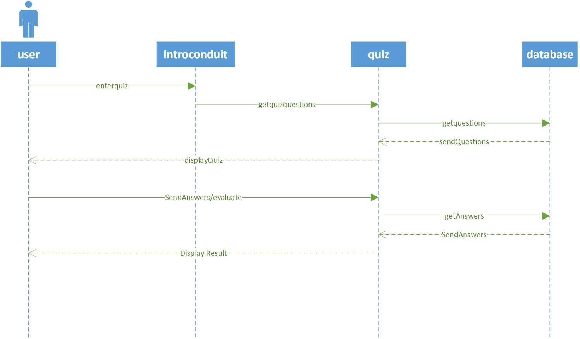

Class Diagram:

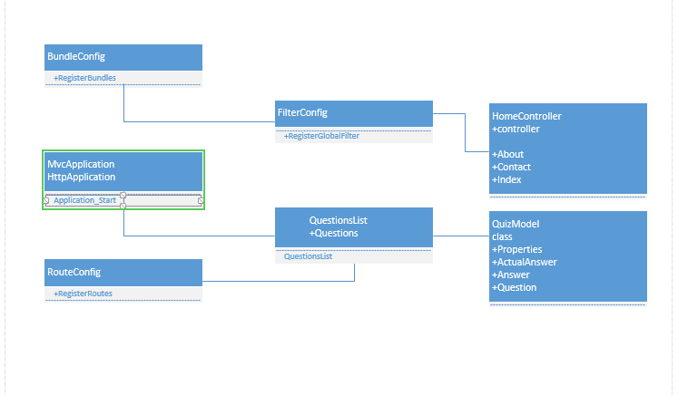

Screen Shots:

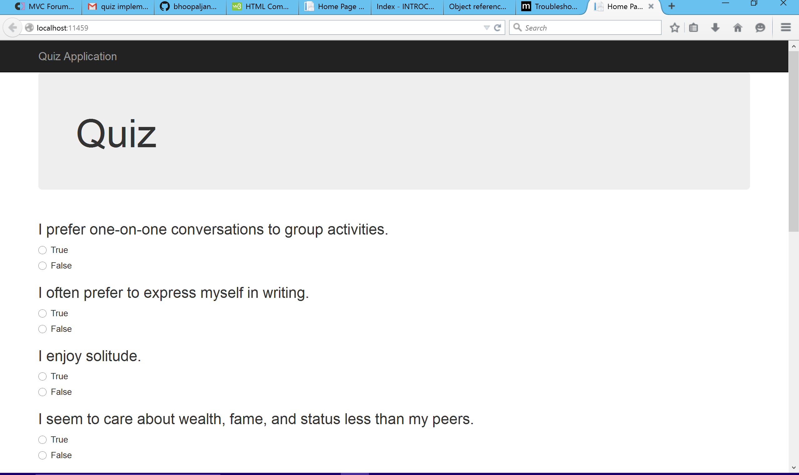

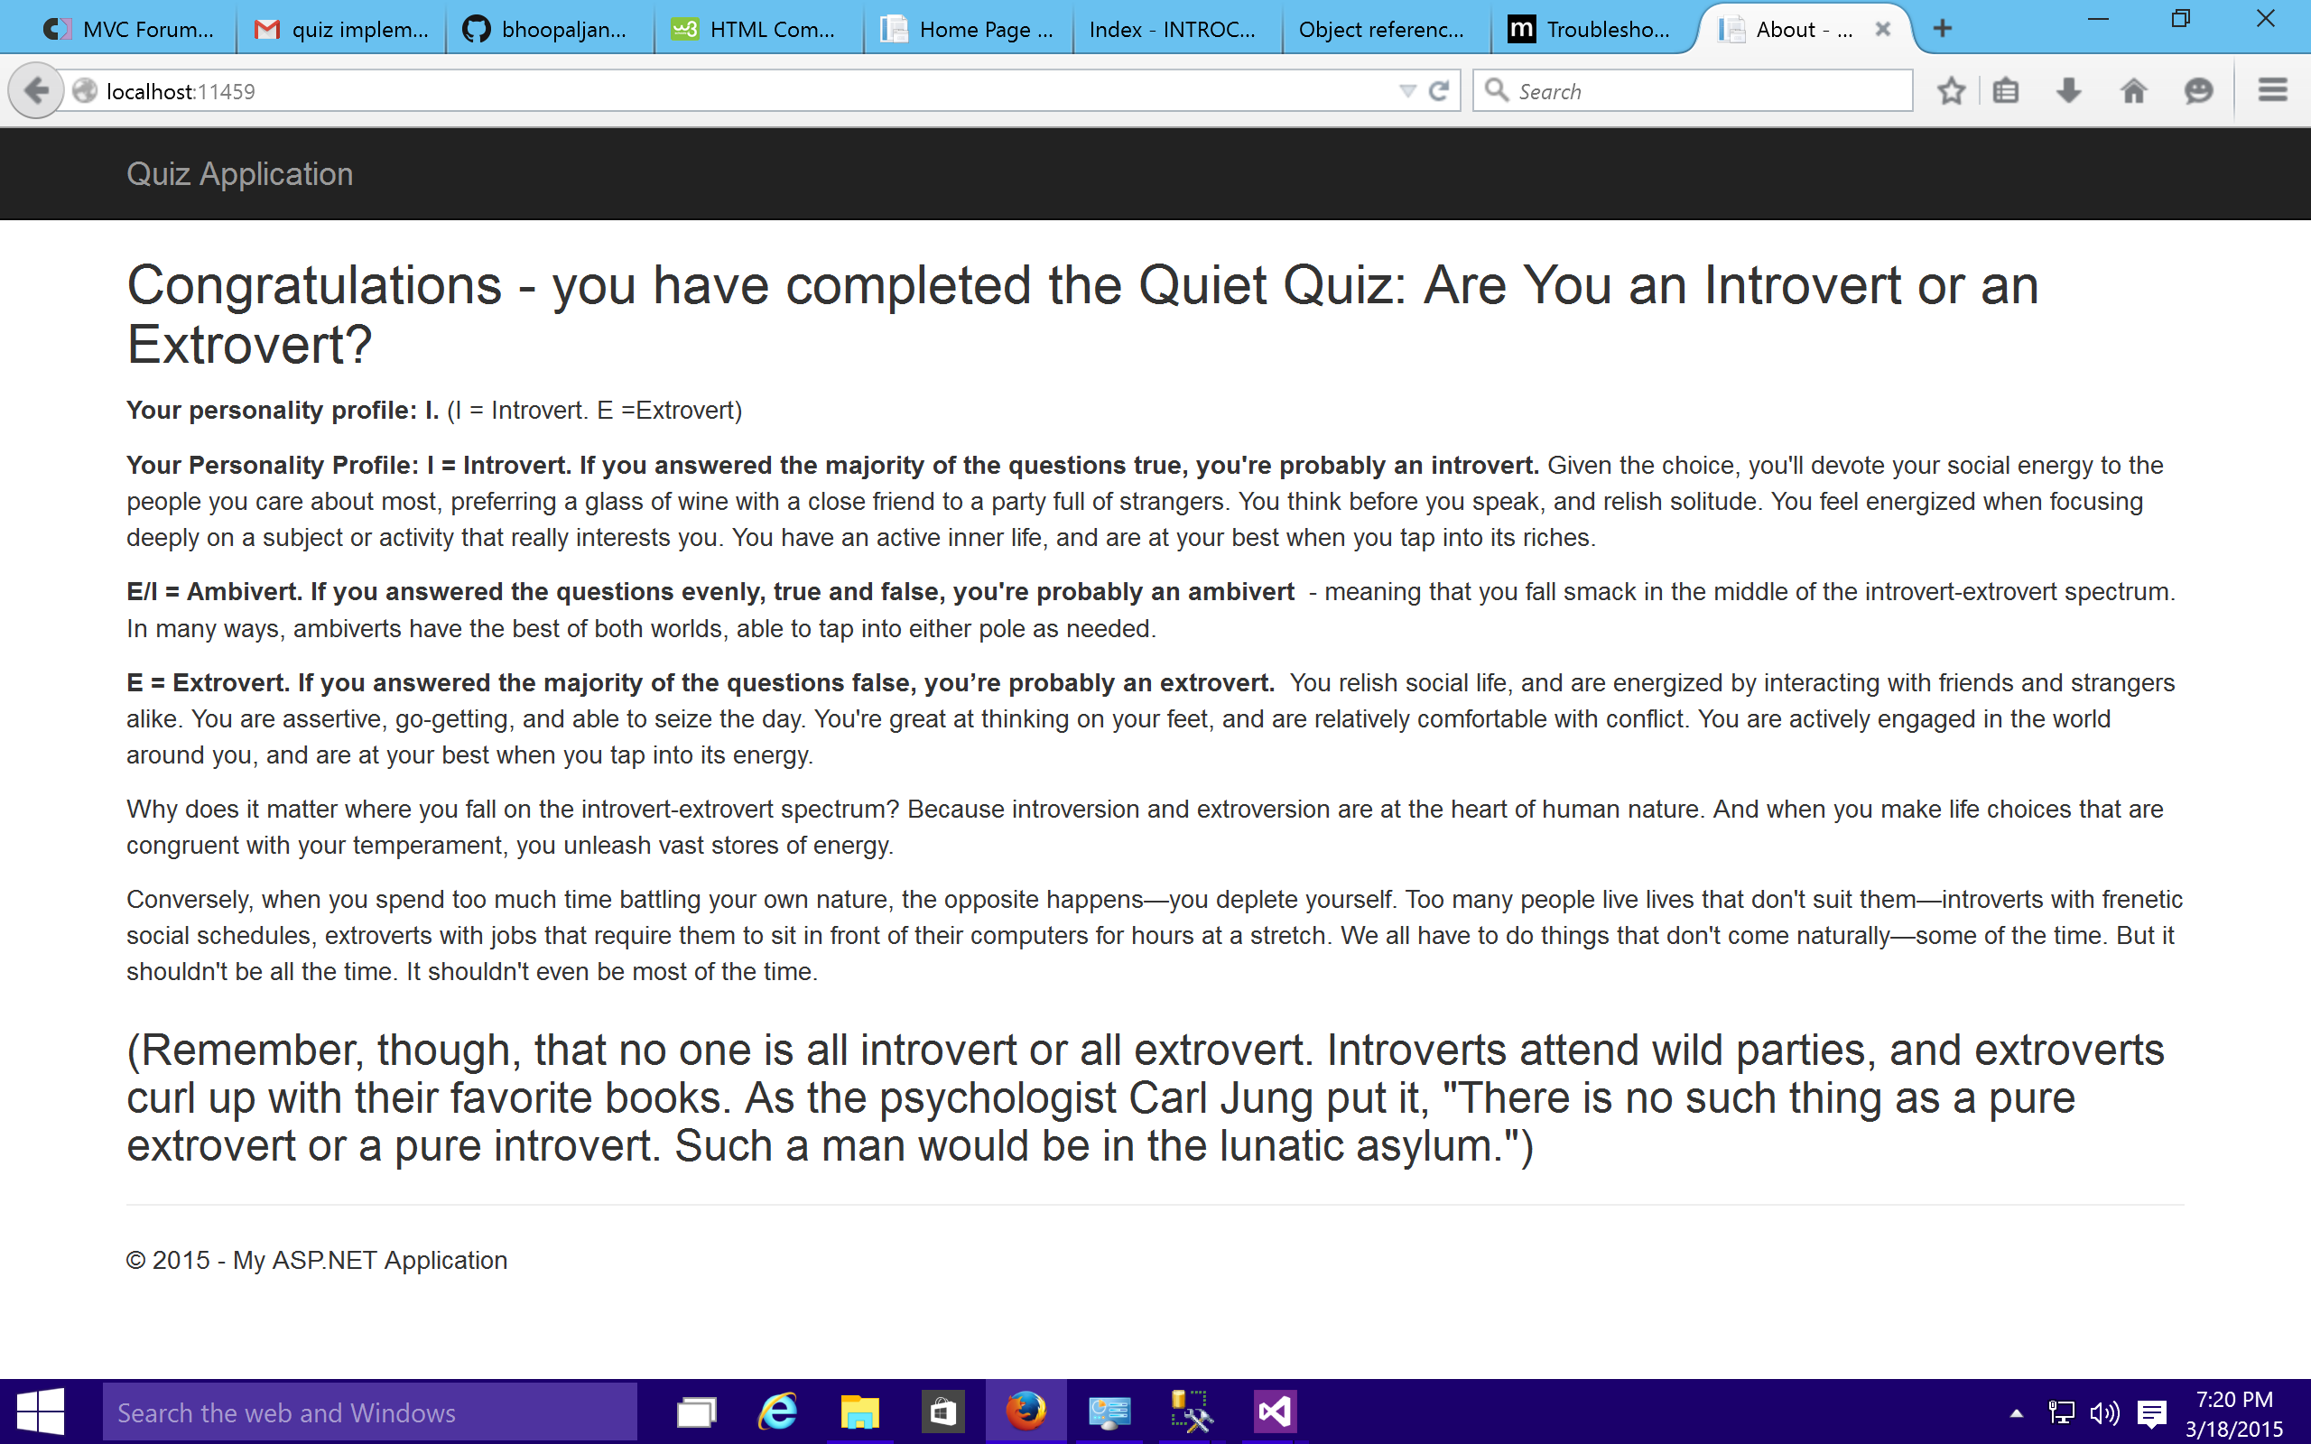

# 2.1: Forum Functionality:

1. Database with the tables required has been created, implementing the forum. A few build errors have to be resolved.
2. More than 60% of development has been completed.
3. I am also trying to use an external open source plugin for the forum functionality but there are a few issues that have to be resolved ie., the custom authorization which was created has to be linking to the forum’s login system for authentication, at present third party authentications are not provided by the external plugins . So what I am trying to do is link the authentication of the external plugin to Introconduit’s authentication to create new users in the forum.
4. Researching on ASP.NET identity framework for authentication purposes.

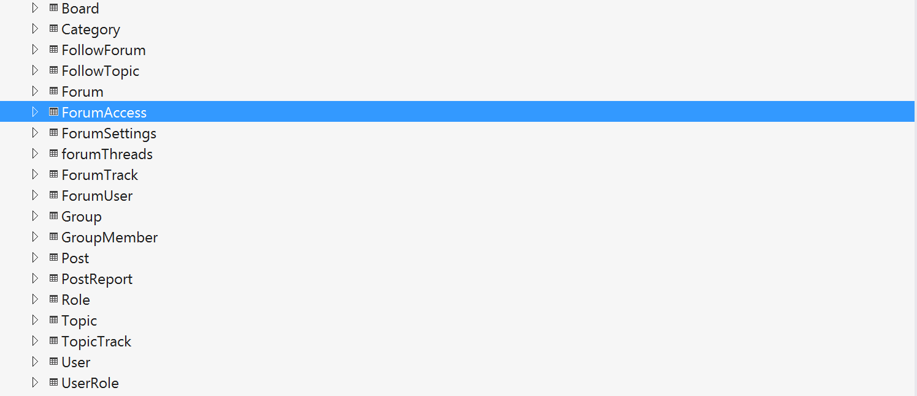

* **Forum**

**Operational Description**: A registered user would be able to post a question or his opinion in this forum, every registered user can post a question or opinion upon which other users will posts their comments or answers, there will be a separate field for admin where he posts his comments or answer. If a non-registered user tries to post something or tries to comment a pop message will appear asking him to register.

**Input/Output:** The registered user can post a question or opinion as input, he/she could comment to other posts as input and the administrator’s view or his comment can be regarded as output. The registered user will have all the privileges to edit, update, or delete his posts and same can be done with comments or answers with other users.

**Constraints/Exceptions:** A non-registered user will not be able post or comment anything, if he/she tries to post anything an exception will be raised asking him to register first.

**Service Flow:** user who wishes to post or comment in the forum

Types something he wishes to post/comment in the text fields

The user can update/edit/delete his post or comment

If a non-registered user tries to post/or comment a pop-up message will be shown asking him to register.

Administrator will give his view in a separate text field.

Reference:

1. http://www.codeproject.com/Articles
2. <http://www.shawnmclean.com/blog/2012/04/simplecrypto-net-a-pbkdf2-hashing-wrapper-for-net-framework/>
3. www.mvcforum.org

4. http://getbootstrap.com

3. ScrumDo .

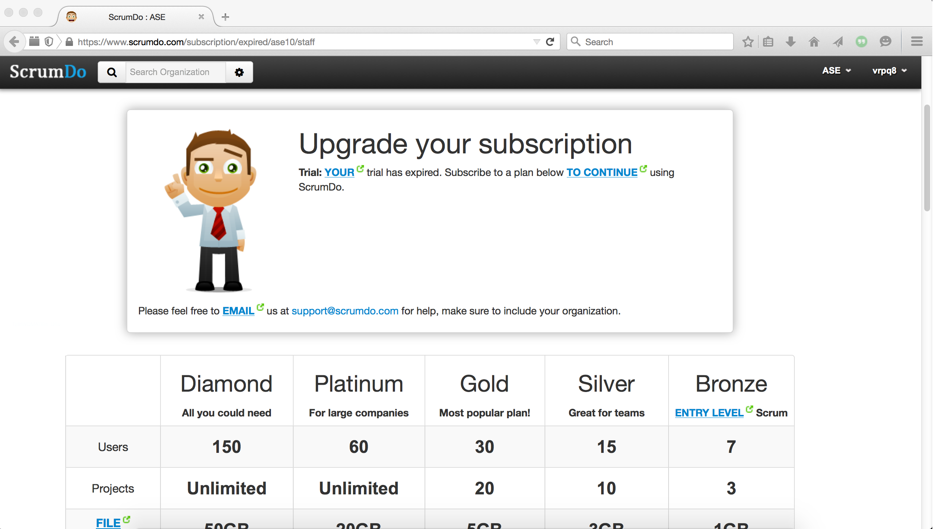

3.1 Implementation status report:

* Work Completed:

QUIZ Application(Karthik).

Forum Table’s and Implementation (Vishnu).

Documentation of Increment 2 and ScrumDo (Vishnu).

Time Taken (30 hours).

* Work to be Completed:

Forum, Resources.

Time estimated (#hours).

* Issues/Concerns:

Testing has to be done.

Forum Implementation on MVC architecture is proving to be a challenge.

Have to Research on implementing rest services in MVC architecture.

ScrumDo Subscription problem.

GITHUB Link:

https://github.com/vishnurainigari/Project